**Append and Pop :: onto List**

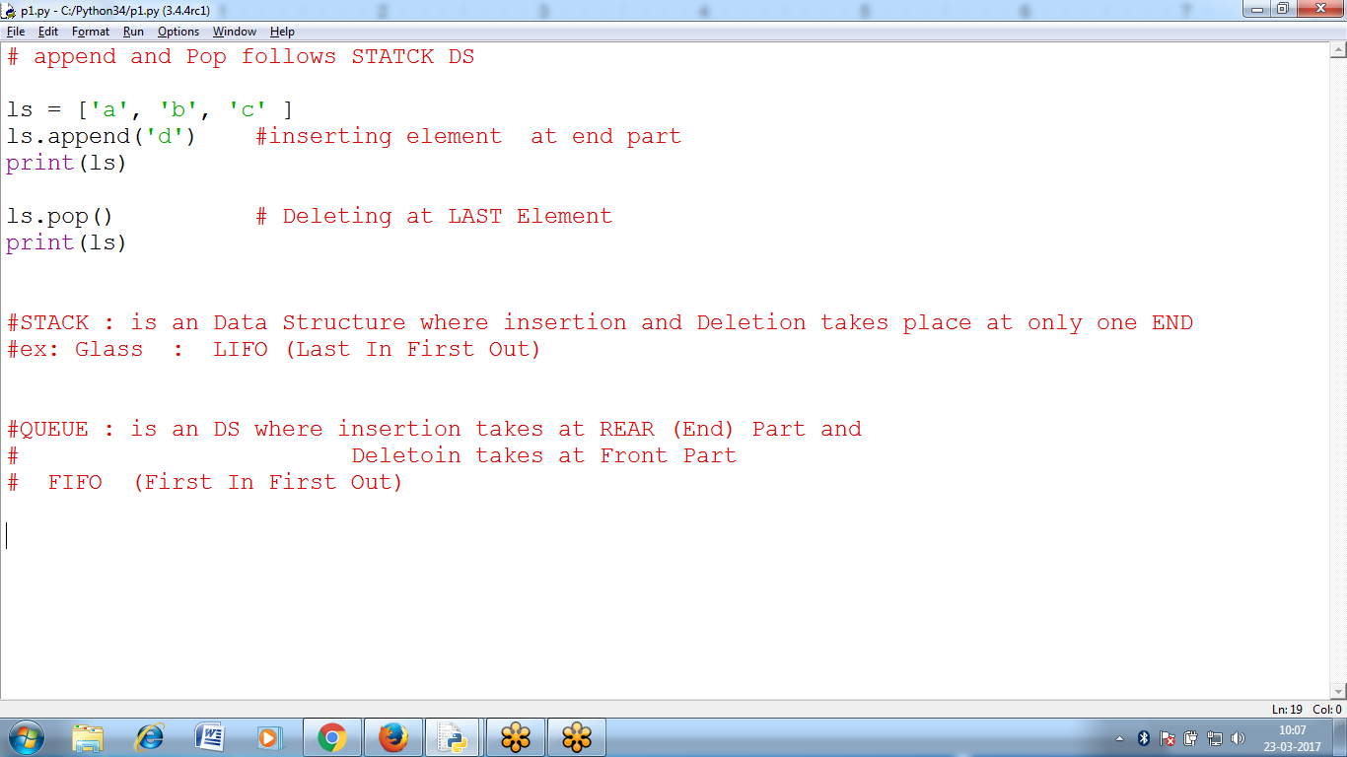

Stack is an Data Structure :

Where insertion and Deletion takes place at only one END : TOP

append() : Insert

pop(): Delete : Top element deleted

Queue is an Data Structure:

Where insertion takes place at LasT (Rear Part)

Where Deletion Takes place at FRONT part

**LIST follows STACK DS**

>>> ls

['raju', 'rani', 'ravi']

>>> ls.append('kiran')

>>> ls

['raju', 'rani', 'ravi', 'kiran']

>>> ls.pop()

'kiran'

>>> ls

['raju', 'rani', 'ravi']

>>>

# append and Pop follows STACK DS

ls = ['a', 'b', 'c' ]

ls.append('d') #inserting element at end part

print(ls)

ls.pop() # Deleting at LAST Element

print(ls)

**LIST Slicing Delete and Insert ::**

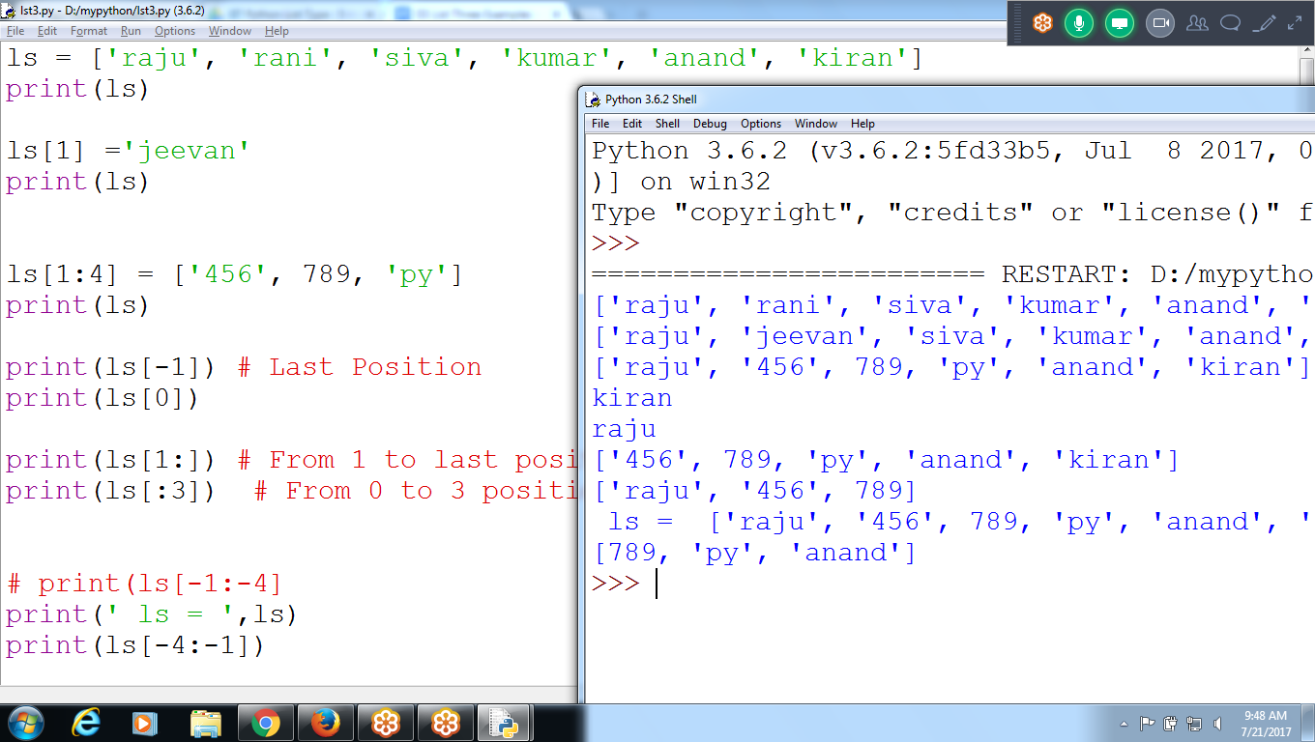

ls = ['raju', 'rani', 'siva', 'kumar', 'anand', 'kiran']

print(ls)

ls[1] ='jeevan'

print(ls)

ls[1:4] = ['456', 789, 'py']

print(ls)

print(ls[-1]) # Last Position

print(ls[0])

print(ls[1:]) # From 1 to last positoin

print(ls[:3]) # From 0 to 3 position

# print(ls[-1:-4]

print(' ls = ',ls)

print(ls[-4:-1])

**Fibonacci Series**

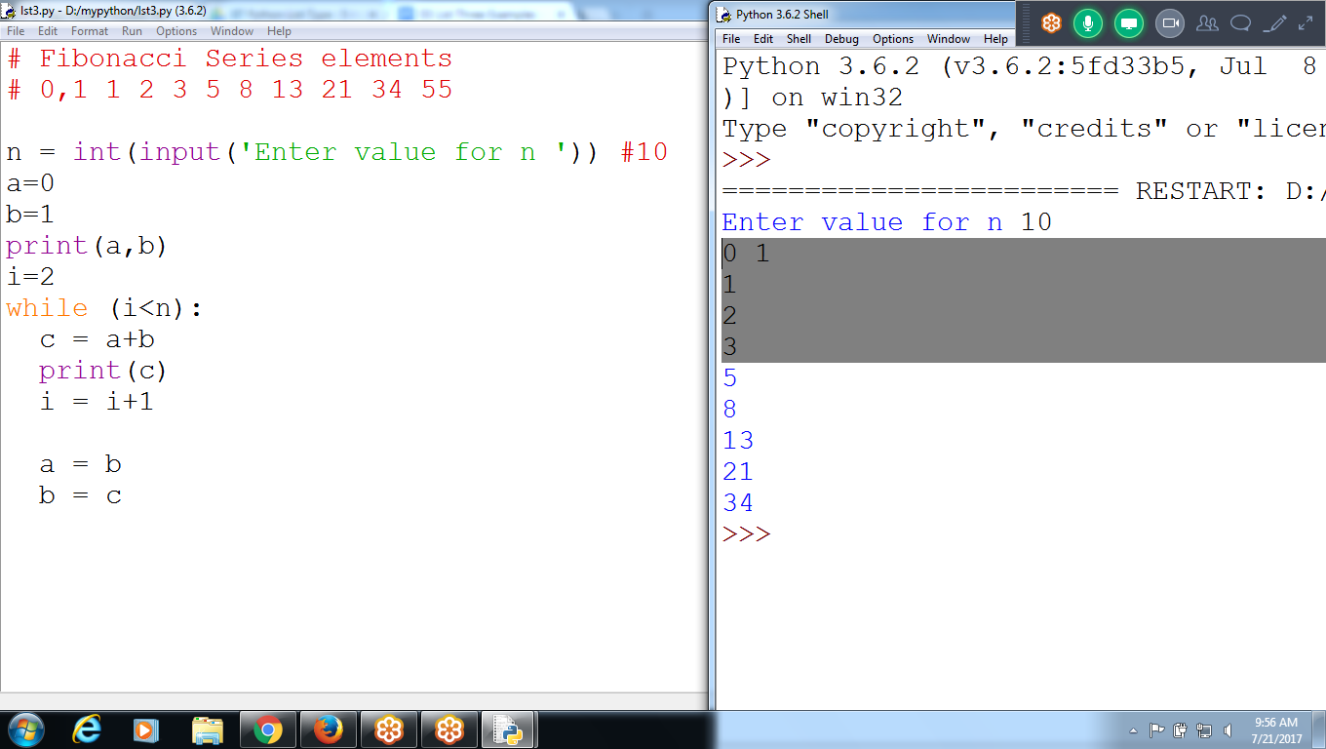

# Fibonacci Series elements

# 01 1 2 3 5 8 13 21 34

n = int(input('Enter value for n ')) #10

a=0

b=1

print(a,b)

i=2

while (i<n):

c = a+b

print(c)

i = i+1

a = b

b = c

Using Multi Assignment Variable

A,b = b, c 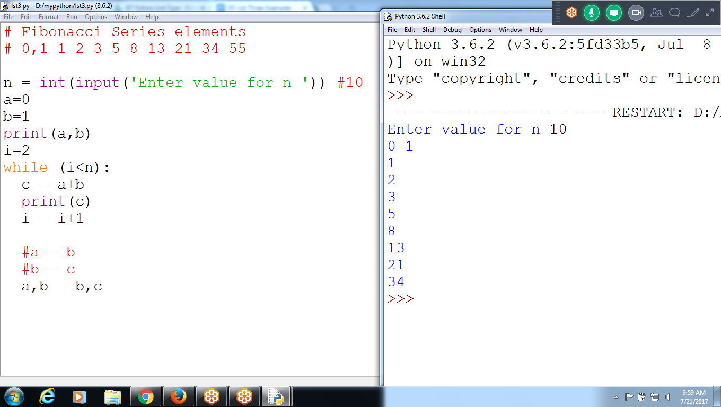

# Fibonacci Series elements

#n =10

# 0 1 1 2 3 5 8 13 21

n = int(input('Enter value for n '))

a = 0

b = 1

print(a,b)

i=2

while(i<=n):

i = i+1

c = a+ b

print(c)

a,b = b,c

**Without C variable using LIST structure**

**Fibonacci Series : Using Append and list**

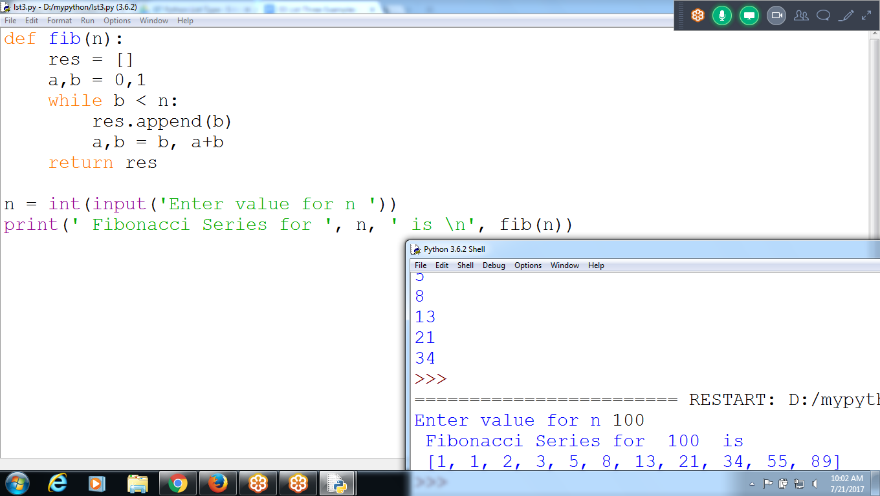

# Fibonacci Series

def fib(n):

res = []

a,b = 0,1

while b < n:

res.append(b)

**a,b = b, a+b**

return res

n = int(input('Enter value for n '))

print(' Fibonacci Series for ', n, ' is \n', fib(n))

**Without List , Directly Printing**

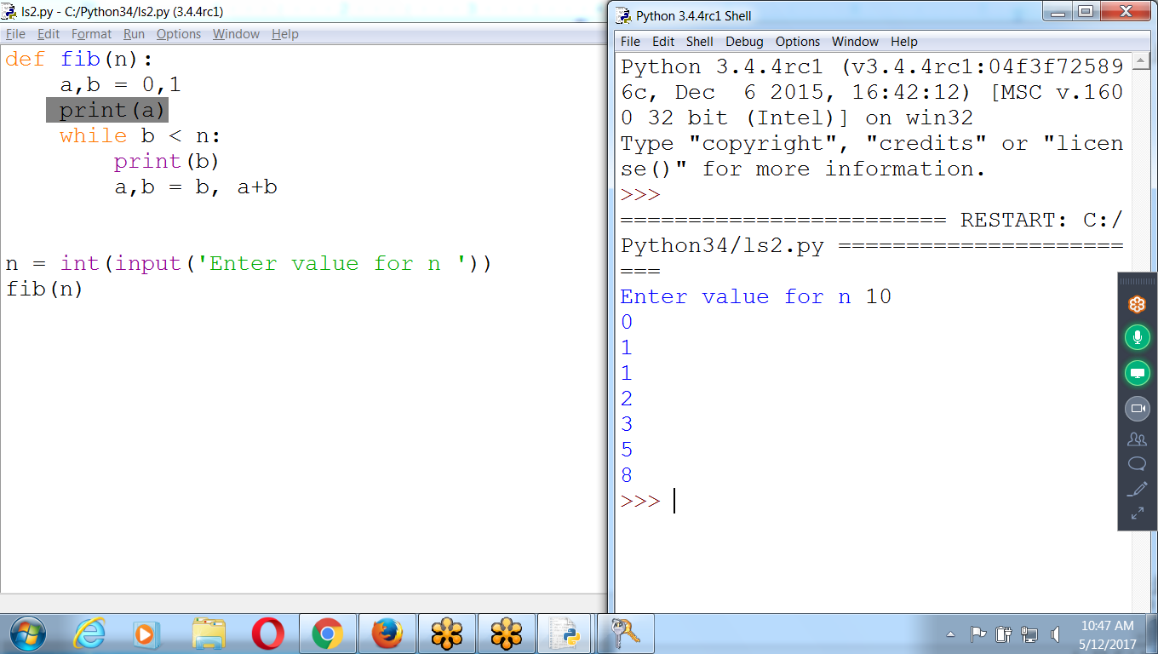

def fib(n):

a,b = 0,1

**print(a)**

while b < n:

**print(b)**

a,b = b, a+b

n = int(input('Enter value for n '))

fib(n)

**ZIP Function**

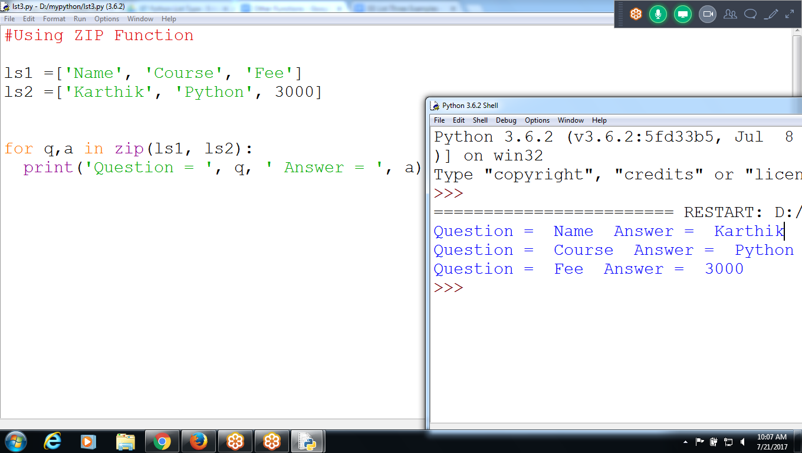

**#Using ZIP Function**

**ls1 =['Name', 'Course', 'Fee']**

**ls2 =['Karthik', 'Python', 3000]**

**for q,a in zip(ls1, ls2):**

**print('Question = ', q, ' Answer = ', a)**

**CHecking Question and answer without ZIP function**

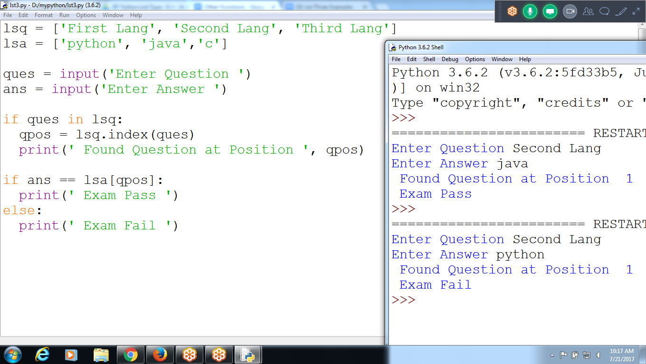

**lsq = ['First Lang', 'Second Lang', 'Third Lang']**

**lsa = ['python', 'java','c']**

**ques = input('Enter Question ')**

**ans = input('Enter Answer ')**

**if ques in lsq:**

**qpos = lsq.index(ques)**

**print(' Found Question at Position ', qpos)**

**if ans == lsa[qpos]:**

**print(' Exam Pass ')**

**else:**

**print(' Exam Fail ')**

**Using ZIP() to validate Question and Answer**

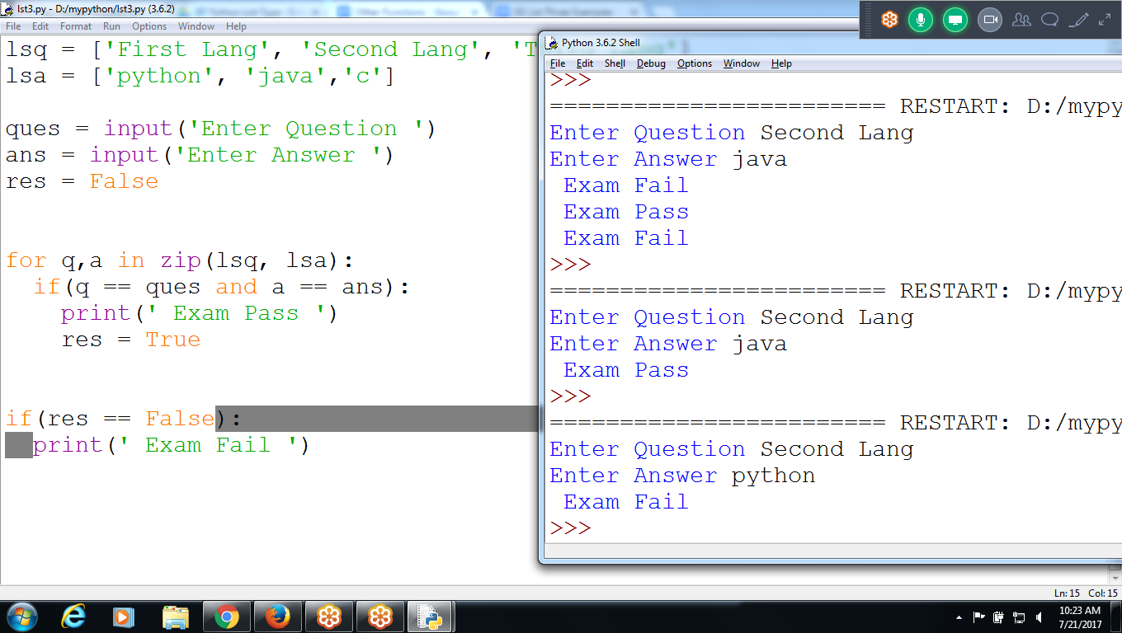

**lsq = ['First Lang', 'Second Lang', 'Third Lang']**

**lsa = ['python', 'java','c']**

**ques = input('Enter Question ')**

**ans = input('Enter Answer ')**

**res = False**

**for q,a in zip(lsq, lsa):**

**if(q == ques and a == ans):**

**print(' Exam Pass ')**

**res = True**

**if(res == False):**

**print(' Exam Fail ')**

**Sum of the values in TWO Lists**

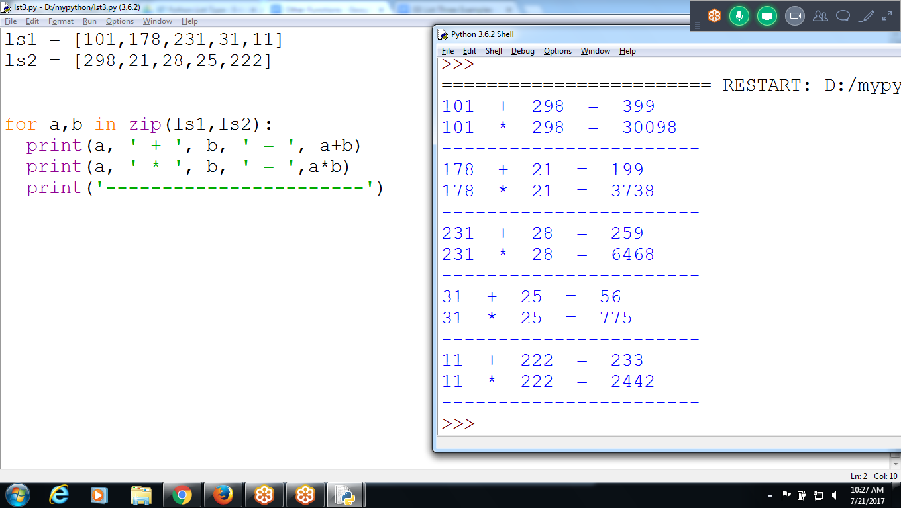

**ls1 = [101,178,231,31,11]**

**ls2 = [298,21,28,25,222]**

**for a,b in zip(ls1,ls2):**

**print(a, ' + ', b, ' = ', a+b)**

**print(a, ' * ', b, ' = ',a*b)**

**print('-----------------------')**

***********************************************************************************************************************************************************************************************************************************************************************************************